Design Document

# System design

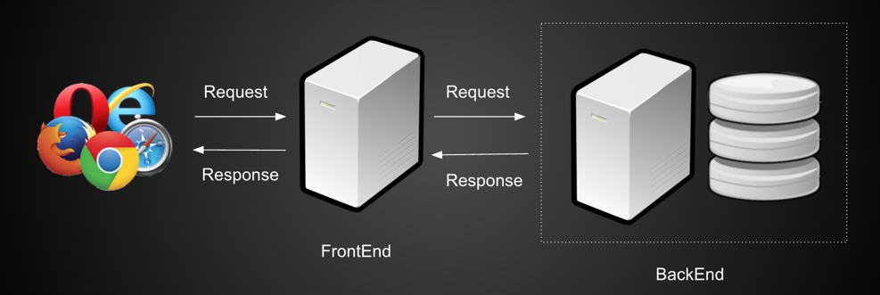

Figure 1 System Architecture

There are two servers in our system. One is frontend server, which would process request sent from browser and redirect the request to the backend server. Backend server is in charge of the interaction with database. After Receiving requests from frontend server, backend server would do the corresponding CRUD (Create, read, update and delete) process. Altering retrieving result from database, backend server would forward the result to the frontend server. And finally, result would be showed on website.

Both frontend server and backend server are built upon Play Framework (we would introduce more in System Implementation section). They communicate with each other through HTTP Request. By doing this, we make our system loose coupling and easily scalable.

We use MySQL as database. And the schema is following.

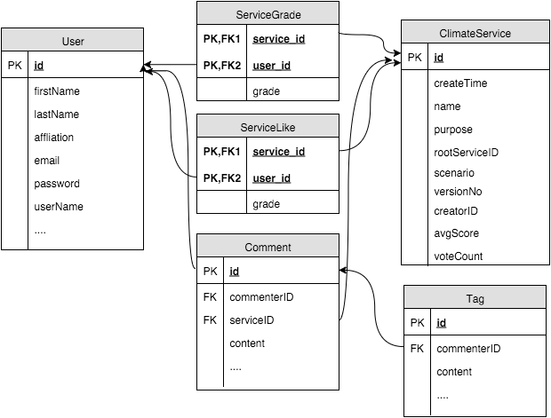

Figure 2 database schema

When designed the schema, we make sure all relations are in BCNF (Boyce–Codd normal form). By following this normalization form, we can make sure there is no redundancy in the system and also make sure each table is lossless and dependency preserved. Details would be discussed in System Implementation section.

Following is our UML of our system.

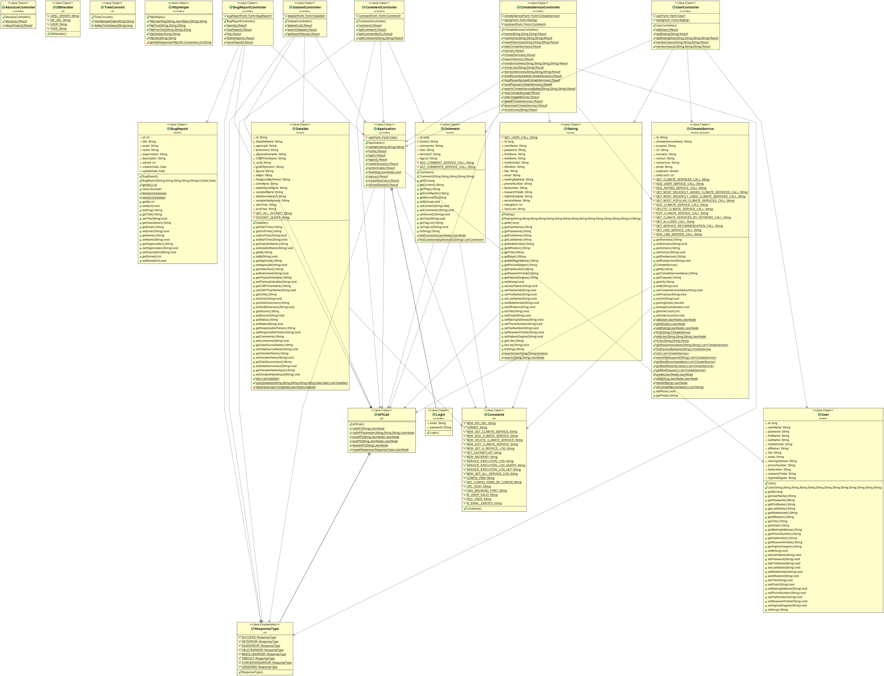

Figure 3 UML Frontend

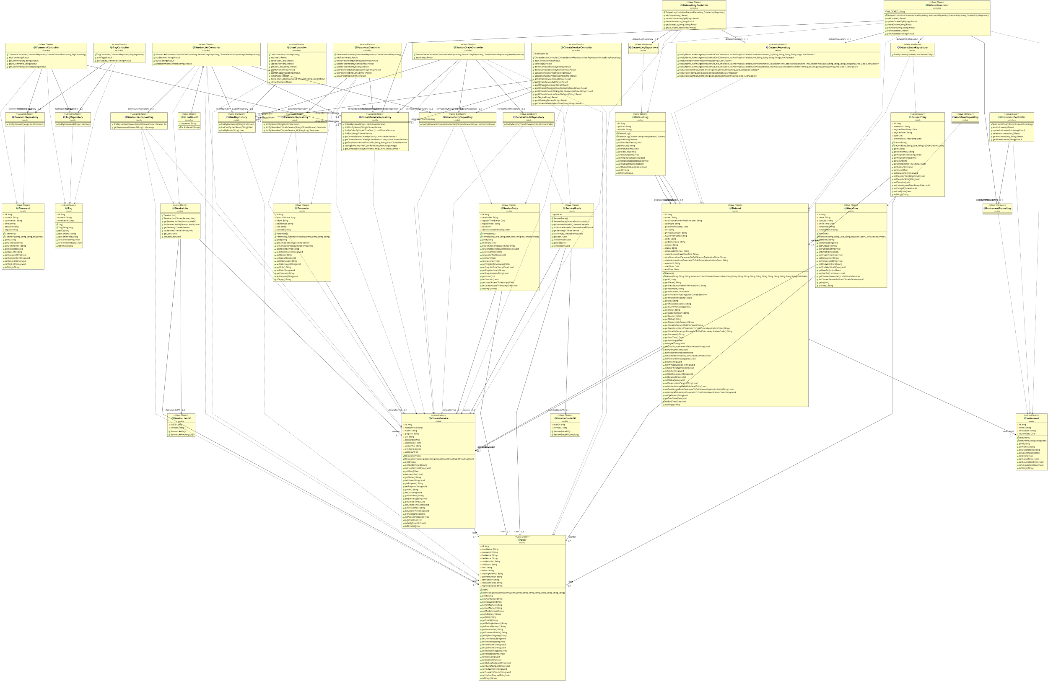

Figure 4 UML Backend